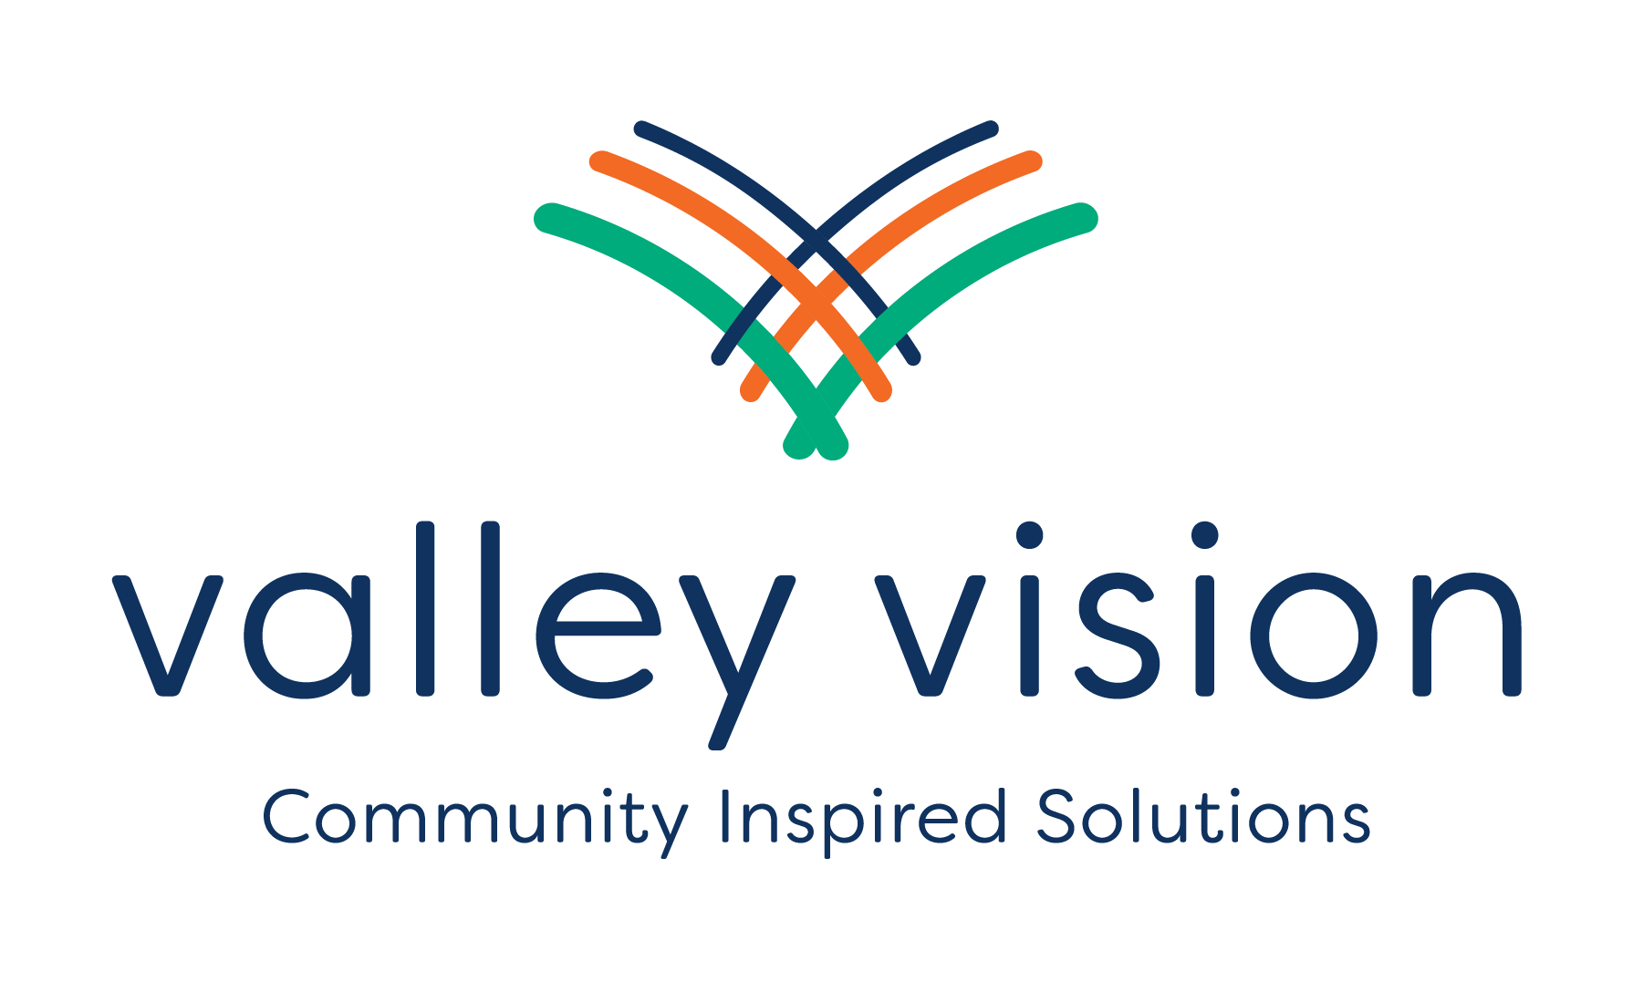
MEETING SUMMARY
Meeting Title | CERF Collaborative Meeting: Summer of Collective Learning, Webinar 1
Date | June 22, 2023 | Start Time | 1:00 pm | End Time | 3:00 pm | Location | Zoom
Facilitator(s) | Evan Schmidt - Lead Facilitator  Richard Dana - Lead Facilitator  Alana Ramsay - Tech Support  Darlene Meza - Notetaker  Christina Craner - Q&A Support  bel Reyes - Q&A Support
Speakers and Guests | Congressman Ami Bera  Dr. Manuel Pastor (Guest Presenter)  Jesus Salazar & Matt Phillips, Governor's Office of Planning and Research  Supervisor Patrick Kennedy, Sacramento County Board of Supervisor

Meeting Purpose & Objectives
- Establish a common knowledge base by participating in collective learning about inclusive economic development
- Provide updates on the CERF program and our region's efforts
- Share info needed to gear up for increasing activities over the coming months

Item 1: Greetings and Welcome Capital Region Collaborative | Agreements & Action Items
Discussion Summary
- Overview of today’s purpose, emphasizing the excitement of collective commitment of community from across diverse sectors to the Capital Region and CERF efforts.
- Explained historical background overview of CERF. A lot has occurred over the past few months
- We are currently in the planning phase
  - Creating regional collaboratives
  - Regional economic plans
- Showed a video from Congressman Bera explaining CERF and his excitement for the kickoff
Item 2: Inclusive Economic Development
Discussion Summary  - Dr. Manuel Pastor  - Explained the COVID shock to our system  - Illustrated the wealth gap  - Revealed inequities in healthcare  - Exposed digital divide  - Exposed the issues in handling immigration status  - We don't need a recovery but a re-imagination and restructuring that challenges inequality and lifts up commonality  - Dr. Pastor believes that CERF can help with this  - We need to understand demography and center on racial equity  - Craft new a economic story  - Economic Solidarity- Book  - Our Economy  - Organized by the people, reflecting values and power  - Mutuality  - Recognize our role in current economy, invest in transforming economy  - Movements  - Shift power relationships, expand circles of belonging  - We should be holding ourselves accountable  - Q&A  - At the local level what are some things we need to address? Local policies)  - Housing affordability  - Transit  - Invest in community college  - Childcare  - Provide jobs to college students  - Flexible class schedule (night classes)  - Counter digital divide  - What are your thoughts on the areas we can address in terms of lacking in disinvested communities to create generational wealth?  - Racial wealth gap needs to be addressed  - Expand micro funding programs, help small business  - Generational lending programs  - How do we balance and push through to equity?  - We need investment if we want equity  - Economic Solidarity explains this very well | - Read Dr. Pastor’s book, Solidarity Economics, available for download at https://solidarityeconomics.org/
Item 3: Capital Region CERF & CERF Adjustments
Discussion Summary  - Reporting what VV has done in the last 90 days  - Convened 20+ member committee to inform development of CERF from capital region  - Development of the Capital Region to CERF structure, processes, and procedures  - Engagement of hoc committee to define key terms of equity, inclusion, and disinvested communities  - Lead Research Partner Identified  - Launched and reviewing proposal for communication partner  - Launched Subregional Hub RFP- currently open  - Explaining the Capital Region CERF structure  - Collaborative (at the center)  - Sub Regional committees (supports the collaborative)  - Leadership Council (steering decision making and functionality  - Valley Vision (Regional Converner, to support all partnerships and carry out deliverables)  - Shared Vision  - Our Process is inclusive …  - Our outcomes are equitable….  - California CERF Updates from Governor’s Office of Planning & Research  - Catalyst Fund  - Push the CERF mission forward through more investment in exploratory projects  - This funding insures that all funding gets expended and reaches communities sooner  - $26.5M per region  - HRTC maintenance $1.5M & Project Development $25M  - Career coordinator $3M, Community Assets Survey $1M, Revolving Loan Fund $5M, Project Management $15M, Anchor Institutions $1M  - Q&A  - Catalyst fund isn't meant to be competitive  - Its meant to fund projects that the HRTC wants to fund  - Regions will not be competing with each other  - What is HRTC?  - High Road Transition Collaborative  - 12 stakeholders that need to be apart of the decision making process in every region  - Can't move the timeline due to the legislation | - Share and communicate public comments for CERF Catalyst Fund Program
Item 4: Going Forward
Discussion Summary  - Working over the upcoming months  - Research & Analysis  - Contracting with Lead Communications Partner  - Contract with Subregional Hub Partners + form subregional committees  - Formation of the Leadership Council  - Upcoming Collaborative Meetings  - Thursday, July 27th, 3pm-5pm  - Thursday, August 24th, 3pm-5pm | - Keep an eye out for invitations to join Research and Communications committees  - Submit proposals for Subregional Hub Partner RFP by June 30. Seeking proposals from Colusa and Yuba/Sutter subregions
Item 5: Closing & Adjourn
Discussion Summary  - Patrick Kennedy  - We need our voices to be heard and be actively engaged  - Open invitation to call upon him for assistance  - Contact Alana Ramsay (VV) or Richard Dana(CSS) | - Recording and materials will be sent to attendees as well as through CERF newsletter

